**Gujarat**

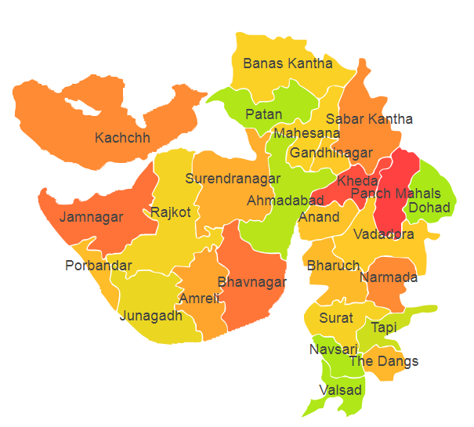

Gujarat comprises of five Agro Ecological Regions (AER) 2,4,5,6 and 19.

**Agro-Eco Region 2:** AER 2 in Gujarat comprises of Banaskantha, Kachchh, Jamnagar, Patan, Porbandar, Rajkot and Surendranagar districts of Western Plain. Kachchh and part of Kathia war Peninsula under Agro Ecological Sub Regions (AESR) 2.2, 2.3 and 2.4.

**Agro-Eco Region 4:** AER 4 in Gujarat comprises of Ahmadabad, Gandhinagar, Khera, Mahesana, Sabar Kantha and Surendranagar districts of Northern Plain and Central Highlands including Aravallis under Agro Ecological Sub Regions (AESR) 4.2.

**Agro-Eco Region 5:** AER 5 in Gujrat comprises of Anand, Bharuch, Bhavnagar, Dahod, Junagarh, Khera, Narmada, Panchhmahal, Rajkot, Surat, Tapi and Vadodra districts of Gujarat Plains & Kathiawar Peninsula under Agro Ecological Sub Regions (AESR) 5.1,5.2 and 5.3.

**Agro-Eco Region 6:** AER 6 in Gujrat comprises of Dangs district of Deccan Plateau under Agro Ecological Sub Regions (AESR) 6.2.

**Agro-Eco Region 19:** AER 9 in Gujrat comprises of Dangs, Navsari and Valsad districts of Western Ghats & Coastal Plain under Agro Ecological Sub Regions (AESR) 19.1.